### Screenify

##### AN INTERNSHIP PROJECT REPORT

***Submitted by***

**Parmar Dixit**

##### [190130107076]

***In partial fulfillment for the award of the degree Of***

#### BACHELOR OF ENGINEERING

***in***

**Information Technology**

**Government Engineering College, Gandhinagar**





#### Gujarat Technological University, Ahmedabad

##### April,2023

 

**Government Engineering College** Sector 28 GIDC, Gandhinagar

Gujarat - 382028, India

### CERTIFICATE

This is to certify that the internship report submitted along with the internship entitled **Screenify** has been carried out by **Parmar Dixit NareshBhai** under my guidance in partial fulfillment for the degree of Bachelor of Engineering in Computer Engineering, 8th Semester of Gujarat Technological University, Ahmedabad during the academic year 2023-24

Prof. Hemani Shah Prof.Jitendra Kumar Dhobi

Internal Guide Head of the Department

 

**Government Engineering College, Gandhinagar Sector 28 GIDC, Sector 28, Gandhinagar**

382028, Gujarat, India

### DECLARATION

We hereby declare that the Internship report submitted along with the Internship entitled **Screenify** submitted in partial fulfillment for the degree of Bachelor of Engineering in Information Technology to Gujarat Technological University, Ahmedabad, is a bonafide record of original project work carried out by me at **La Net Team Software Solutions Pvt. Ltd.** Under the supervision **Mr. Hitesh Pandya** and that no part of this report has been directly copied from any students report or taken from any other source, without providing due reference.

Name of the Student Sign of Student

P a r m a r D i x i t

### ACKNOWLEDGEMENT

I would like to express my sincere gratitude and appreciation to all those who have supported me during my internship at La Net Team Software Solutions Pvt. Ltd. I am thankful to Mr. Hitesh Pandya, who provided me with constant guidance, encouragement, and support throughout my internship. Their vast knowledge, valuable insights, and expertise in the field of Web Development that helped me develop new skills and broaden my understanding of the industry. I am also grateful to the entire team at La Net Team Software Solutions Pvt. Ltd for providing me with a conducive work environment and giving me the opportunity to work on various projects that have helped me improve my technical skills. I would also like to thank my colleagues for their support and valuable feedback that helped me learn and grow during my internship.

Finally, I am grateful to everyone who contributed to my learning experience at La Net Team Software Solutions Pvt. Ltd. It was an invaluable experience that I will take with me throughout my career.

**Parmar Dixit**

### ABSTRACT

*Screenify is a web application built using React JS and Node.js with MongoDB as the backend database. The website provides a sleek and user-friendly interface where users can browse and stream movies and TV shows. The project leverages the power of MongoDB's document-based structure to store and retrieve movie and TV show information, including availability and recommended content. Users can create and manage their accounts, save their favorite movies and TV shows, and get personalized recommendations based on their viewing history. The site also has an admin portal where administrators can manage content, view user history, and update recommendations. Overall, Screenify is designed to provide a seamless and enjoyable streaming experience for users while providing easy management for administrators.*

#### LIST OF FIGURES

|  |  |  |
| --- | --- | --- |
| **Figure No** | **Figure Description** | **Page No** |
| Figure 4.1.1 | Use Case Diagram | 10 |
| Figure 4.1.2 | Activity Diagram | 11 |
| Figure 4.2.1 | Login Screen and otp screen | 12 |
| Figure 4.2.2 | Dashboard and Profile | 13 |
| Figure 4.2.3 | Loan Application form | 14 |
| Figure 4.2.4 | Pending Application | 15 |
| Figure 4.2.5 | Accepted Application | 16 |
| Figure 4.2.6 | Rejected Application | 17 |
| Figure 4.2.7 | Active Loan | 18 |
| Figure 4.2.8 | Complete loan | 19 |

**SYMBOLS FOR USE CASE DIAGRAM:**

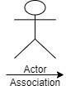

**SYMBOLS FOR SYSTEM FLOW DIAGRAM:**

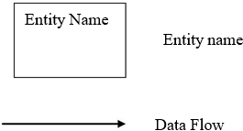

|  |  |  |
| --- | --- | --- |
| **Acknowledgement Abstract**  **List of Figures List of Tables List of Symbols**  **Table of Contents** | | **i ii iii iv v**  **vi** |
| **Chapter: 1** | **Overview of the Organization**   * 1. History of Organization   2. Scope of Work   3. Organization Chart   4. Capacity of Organization | **1**  **2**  **2**  **2** |
| **Chapter: 2** | **Introduction to Project**   * 1. Introduction   2. Purpose   3. Objective   4. Scope   5. Technologies used | **4**  **4**  **4**  **0**  **0** |
| **Chapter: 3** | **System Analysis**   * 1. Study of Current System   2. Problem and Weaknesses of Current System   3. Requirements of New System      1. User Requirements      2. System Requirements   4. System Feasibility      1. Technical Feasibility      2. Time Schedule Feasibility      3. Operational Feasibility      4. Implementation Feasibility   5. Proposed System      1. Advantages of Proposed System | **6**  **6**  **6**  **6**  **6**  **7**  **7**  **7**  **7**  **8**  **8**  **8** |

|  |  |  |
| --- | --- | --- |
| **Chapter: 4** | **System Design**   * 1. Detail Design      1. Use-case Diagram      2. Activity Diagram   2. Database Design   3. Screens | **9**  **10**  **10**  **11**  **12**  **0** |
| **Chapter: 5** | **Implementation Planning**   * 1. Implementation Environment   2. Program/Modules Specification   3. Coding Standards   4. Coding Scenario | **20**  **21**  **21**  **21**  **22** |
| **Chapter: 6** | **Testing**   * 1. Testing Plan/ Strategy   2. Testing Methods      1. Test Cases | **23**  **24**  **25**  **26** |
| **Chapter: 7** | **Limitations and Future Enhancement**   * 1. Limitations   2. Future Enhancement | **30**  **31**  **31** |
| **Chapter: 8** | **Conclusions** | **33** |
| **References** | | **34** |

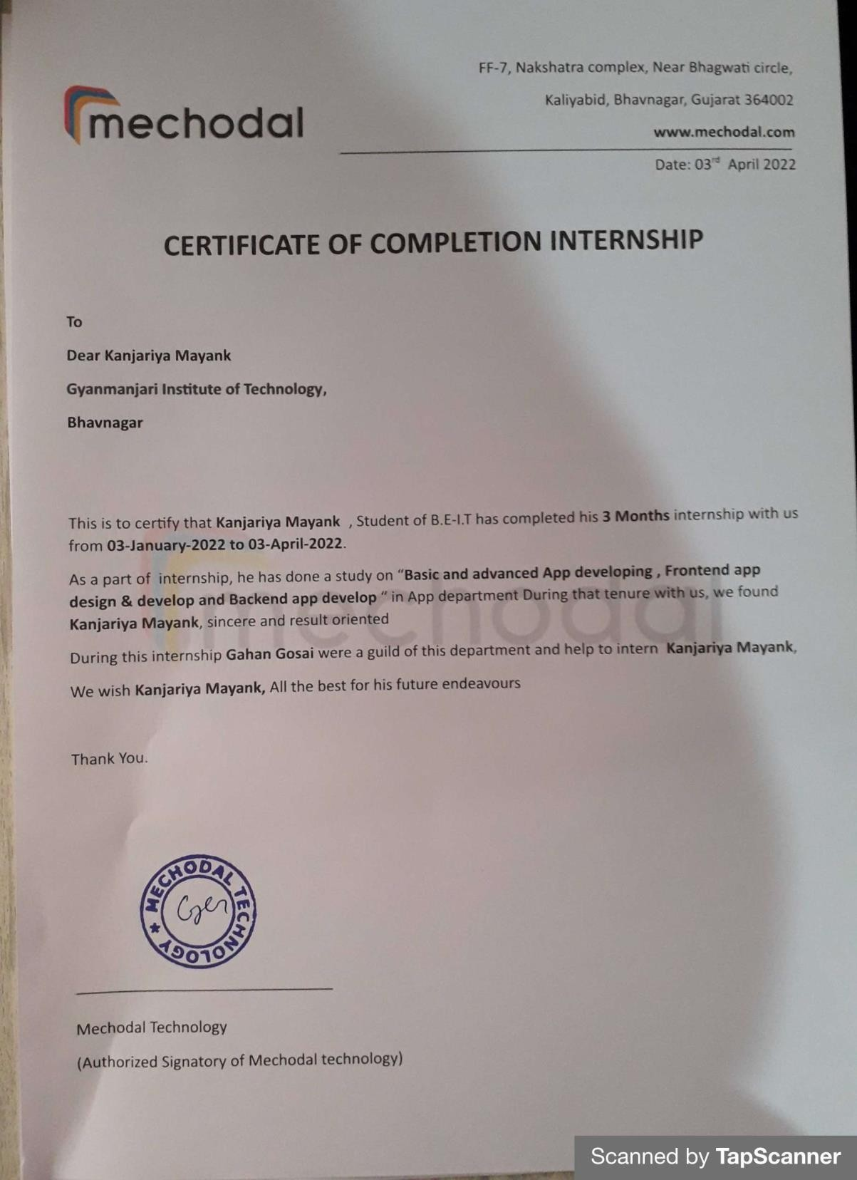

# Chapter 1: Overview of the Organization

#### History of Organization

* 1. **Scope of Work**

#### Organization Chart

* 1. **Capacity of Organization**

#### History of Organization:

La Net Team is an India based software outsourcing company that offers high quality and cost effective software development service to its clients. We strive for on time delivery of the projects and adhere to stringent quality standards.

We offer flexible and cutting edge solutions that help our clients to operate more efficiently and gain an edge over their competitors. We offer high quality offshore software engineering and programming talent that can be leveraged to gain competitive advantage. We believe in delivering smart business solutions through smart usage of technology and continuously focus on quality of deliverables to our clients.

Our wide range of services include website designing, e-commerce services, Android and IOS Applications, Graphic and Logo design, Website Templates, Website Marketing, Product Development, Software Development etc.

Our local presence guarantees cost advantages specially for the key locations that we are situated in. We strive to upgrade our domain expertise to help us provide not only IT services but valuable business services to our clients. Our primary goal is to help the client to focus on his business and leave the onus upon us to deliver what they need to run their business and make it more competitive through technology.

To ensure that our customers get exactly what they need, we offer a variety of solutions that can be customized, combined, or deployed right out of the box and integrated with existing Enterprise applications.

#### Scope Of Work

We put resources into development to enable our customers to release new potential over their associations. What makes La Net Team one of a kind is our pool of talented developers, industry skill, and a genuine comprehension of what to do so as to succeed. With an industry experience that traverses quite a few years, we offer a plenty of customer driven services by empowering undertakings to accomplish upper hand through adaptable and cutting edge worldwide delivery models. Our wide range of services include website designing, e-commerce services, Android and IOS Applications, Graphic and Logo design, Website Templates, Website Marketing, Product Development, Software Development etc.

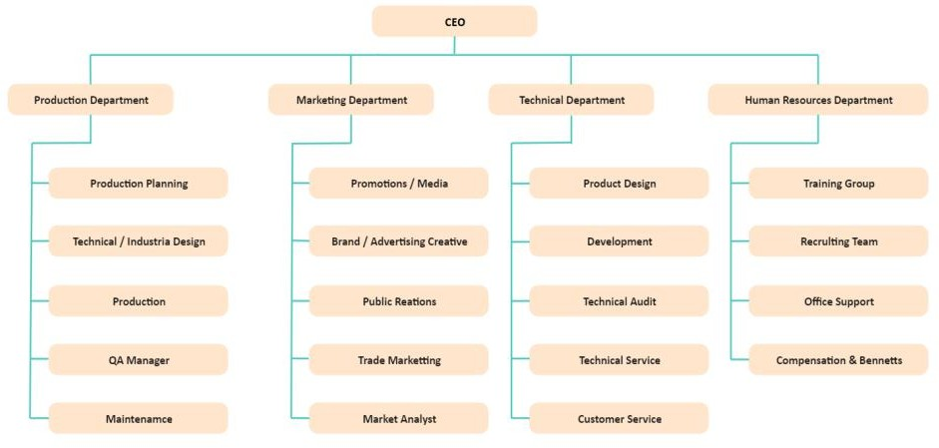

#### Organization Chart

* 1. **Capacity of Organization**

Our company strength is about 250 employees and our company has two headquarters one in Surat.

# Chapter 2: Introduction to Project

#### Introduction

* 1. **Purpose**

#### Scope

* 1. **Objective**

#### Technologies Used

* 1. **Introduction:**

The Screenify project is a cutting-edge solution designed to provide a seamless and efficient streaming experience for users. The project is built using ReactJs and nodeJs, a powerful platform that allows developers to create dynamic and interactive user interfaces with ease. The project's database is implemented using MongoDB, a flexible and scalable NoSQL database that offers efficient data storage and retrieval. By combining NodeJs and MongoDB, the project provides fast and reliable performance, even with heavy traffic.

The website's user-friendly interface allows users to easily browse and stream movies and TV shows, create and manage their profiles, and add titles to their watchlist. In addition, administrators can use the admin portal to manage content, view user history, and track analytics.

Overall, this Screenify project is a robust and scalable solution that provides a seamless platform for users to stream their favorite movies and TV shows, and for businesses to reach out to their audience and streamline their operations.

#### Purpose:

The purpose of this Screenify is to provide a user-friendly platform for streaming movies, TV shows, and other video content online. By offering a wide range of content options, users can browse and watch their favorite shows and movies from the comfort of their own homes. The website is designed to be intuitive and easy to use, making it accessible to a wide range of users.

In addition, the Screenify allows users to personalize their viewing experience by creating profiles and curating a list of their favorite shows and movies. This feature enables users to easily find their preferred content and receive recommendations for new content based on their viewing history. The platform also provides users with access to exclusive content that may not be available on other streaming services.

The Screenify also offers businesses the opportunity to reach a wider audience through online streaming. By going online, businesses can tap into a global market and offer their content to users from all over the world. This increases the potential customer base and opens up new revenue streams for the company. Additionally, the platform allows businesses to track and analyze user behavior, such as viewing habits and preferences, to make informed decisions about content offerings and marketing strategies.

#### Scope:

* + 1. Dealer Login id and password are generated by admin side.
    2. User can login through id and password.
    3. Dealer app dealer fill the form for user.
    4. User id and password are given by dealer.
    5. User can not fill the loan applicaton form

#### Objective:

ShopZen is an e-commerce website that allows businesses to showcase and sell their products online. The objectives of ShopZen are as follows:

1. Provide a user-friendly platform: The main goal of ShopZen is to provide a user- friendly platform that allows customers to easily search and buy products online. The website should be easy to navigate and provide a seamless shopping experience.
2. Improve brand visibility: ShopZen should help businesses increase their brand visibility by showcasing their products online and promoting their brand through digital marketing strategies. The site should include features such as product reviews, personalized recommendations, and social media integration to help businesses build their brand identity.
3. Increase sales: ShopZen should be designed to increase sales by providing businesses with efficient tools to manage their product catalog, process orders and accept payments online. The site should also include features such as discount codes, upselling and cross-selling to encourage customers to make additional purchases.
4. Improve customer satisfaction: ShopZen should be designed to improve customer satisfaction by providing reliable customer service, easy returns and refunds, and a secure payment process. The site should also include features such as product descriptions, images, and reviews to help customers make informed purchasing decisions.
5. Collect customer data: ShopZen should help businesses collect customer data such as purchase history, preferences, and search queries. This data can be used to make informed business decisions about product offerings, pricing, and marketing strategies.
6. Expand your market reach: ShopZen should help businesses expand their market reach beyond their local or regional markets by reaching out to global markets and selling their products to customers from around the world. The website should be designed to support multiple currencies and languages to make it easy for customers around the world to store.

Overall, ShopZen's goal is to provide businesses with an efficient platform to showcase and sell their products, improve customer satisfaction, increase sales, and enhance their brand visibility.

#### Technologies Used:

* + 1. **Design:**
       - HTML
       - CSS
       - Bootstrap 5
       - Core Ui

#### Logic:

* + - * React.js
      * React Redux

#### Database:

* + - * Google Firebase

# Chapter 3: System Analysis

#### Study of Current System

* 1. **Problem and Weaknesses of Current System**

#### Requirements of New System

* 1. **System Feasibility**

#### Proposed System

* 1. **Study of Current System**

E-commerce has grown rapidly in recent years. More and more consumers are using online shopping because it is more convenient and offers a wider selection of products. The current e-commerce system in today's market is dominated by various platforms such as Amazon, eBay, and Walmart. These platforms have made it easy for retailers to set up online stores and sell their products to a larger audience. The advent of mobile commerce has also made shopping more convenient, as consumers can purchase products through their smartphones. Social media integration has also enabled businesses to market their products to a larger audience. Despite challenges such as security concerns and competition, the e-commerce industry is expected to continue growing in the coming years.

#### Problem and Weaknesses of Current System

An online e-commerce website may have various problems and weaknesses, including:

* + - **Technical issues:** technical issues such as website downtime, slow load times, and broken links can negatively impact the user experience and discourage customers from completing their purchases.
    - **Security vulnerabilities:** Online e-commerce websites store sensitive customer data such as payment details and personal information. Therefore, security breaches and hacker attacks can lead to loss of customer trust and financial losses for the company.
    - **Competition:** The e-commerce market is highly competitive, and companies need to constantly innovate and improve their online offerings to stay ahead of the competition.
    - **Inventory management:** Managing inventory can be challenging for e- commerce businesses, as they need to ensure they have enough stock to meet customer demand while avoiding overstocking, which can lead to

waste and financial loss.

* + - **Shipping and logistics:** E-commerce companies need to ensure that they have reliable shipping and logistics partners to deliver products to customers quickly and efficiently.
    - **Returns and customer care:** Handling returns, refunds, and customer inquiries can be time-consuming and difficult for e-commerce companies, and requires dedicated staff and systems for effective management.
    - **Payment processing:** E-commerce businesses need to provide customers with secure and convenient payment options, which can be challenging to set up and manage.
    - **Website design and usability:** a poorly designed website can deter customers and hurt sales. E-commerce companies need to offer a user- friendly website with a seamless checkout process to entice customers to complete a purchase.
    - **Reliance on third-party platforms:** E-commerce businesses that rely heavily on third-party platforms for advertising or sales are vulnerable to sudden changes in policies or pricing structures that can negatively impact their business.

Overall, e-commerce businesses need to be aware of these issues and vulnerabilities and take proactive measures to mitigate them and ensure a successful and sustainable online presence.

#### Requirements of New System

###### User Requirements

The new e-commerce system should provide a user-friendly interface that is easy to

navigate and search for products. It should offer a secure and convenient payment system with multiple payment options. The system should also offer a personalized shopping experience with recommendations based on the user's preferences and purchase history. It should offer the ability to track orders and provide real-time delivery status information. The system should also allow for easy returns and refunds. In addition, the system should have strong security measures in place to protect user data and ensure a safe shopping experience. Finally, the system should be available 24/7 and provide reliable customer support.

###### System Requirements

* + - * **Usability**

The UI of the ShopZen should be user friendly so that users can navigate easily through it.

* + - * **Reliability**

Error handling mechanism must be robust to avoid failure of operation and in case of server failure the payment should be reverted to the user without any due harm.

#### System Feasibility

The feasibility of system can be tested in four dimensions:

###### Technical Feasibility

Since the project uses reliable tools such as open source technologies like react js and firebase, the system can be implemented efficiently and without any hassles. The duo of this technology can process data and queries efficiently and also create user-friendly applications. Therefore, this project has a good technical feasibility.

###### Time Schedule Feasibility

The time feasibility of a new e-commerce website depends on several factors such as the complexity of the website, the availability of resources, and the experience of

the development team. A realistic schedule with clear milestones and contingency plans should be established to ensure timely completion of the project.

###### Operational Feasibility

The operational feasibility of a new e-commerce website is high because the necessary technology and infrastructure are already in place and the demand for online purchases is increasing. However, factors such as usability, security and scalability should be considered when designing and implementing the website to ensure long-term success.

###### Implementation Feasibility

The requirements mentioned above can be fulfilled using various technologies available. React js the implementation of the project is feasible.

#### Proposed System

The proposed e-commerce system is designed to provide a user-friendly interface with mobile responsiveness, secure payment processing, and personalized recommendations. It also offers efficient order processing, 24/7 customer support, robust search capabilities, and integration with social media. Multiple shipping options, advanced inventory management, and comprehensive analytics and reporting are also included. The system aims to provide customers with a seamless shopping experience while enabling the company to effectively manage operations and optimize sales.

* + 1. ***ADVANTAGES OF PROPOSED SYSTEM:***
       - Very fast and accurate.
       - User-friendly interface.
       - Secure Payment processing.
       - Quick checkout process.
       - 24/7 customer support.
       - Easy way to payment.
       - Multiple shipping options.

# Chapter 4: System Design

#### Detail Design

* + 1. **Use-Case Diagram**

#### Activity Diagram

* 1. **Database Design**

#### Screens

* 1. **Detail Design**

##### C:\Users\gener\Downloads\WhatsApp Image 2023-04-23 at 6.34.21 PM.jpegUse-Case Diagram

**[Fig.4.1.1: Use Case Diagram]**

##### Activity Diagram

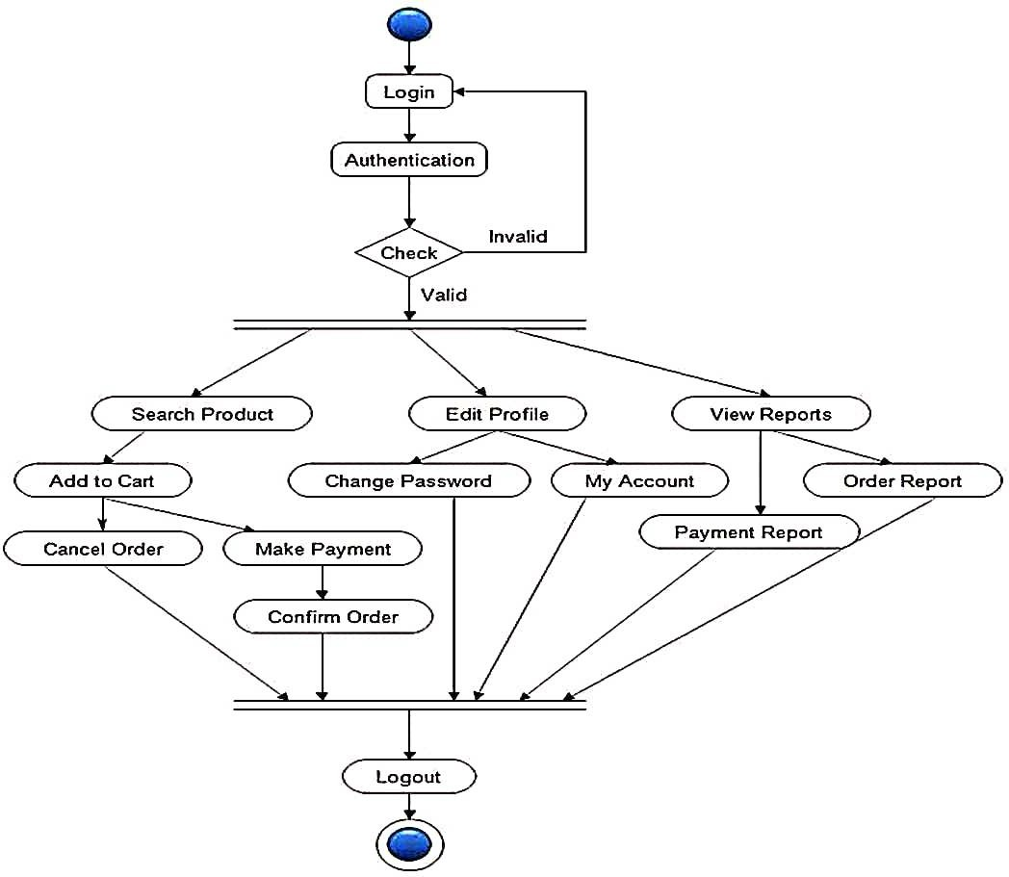

**[Fig.4.1.2: Activity Diagram]**

#### Database Design

##### Firebase Database

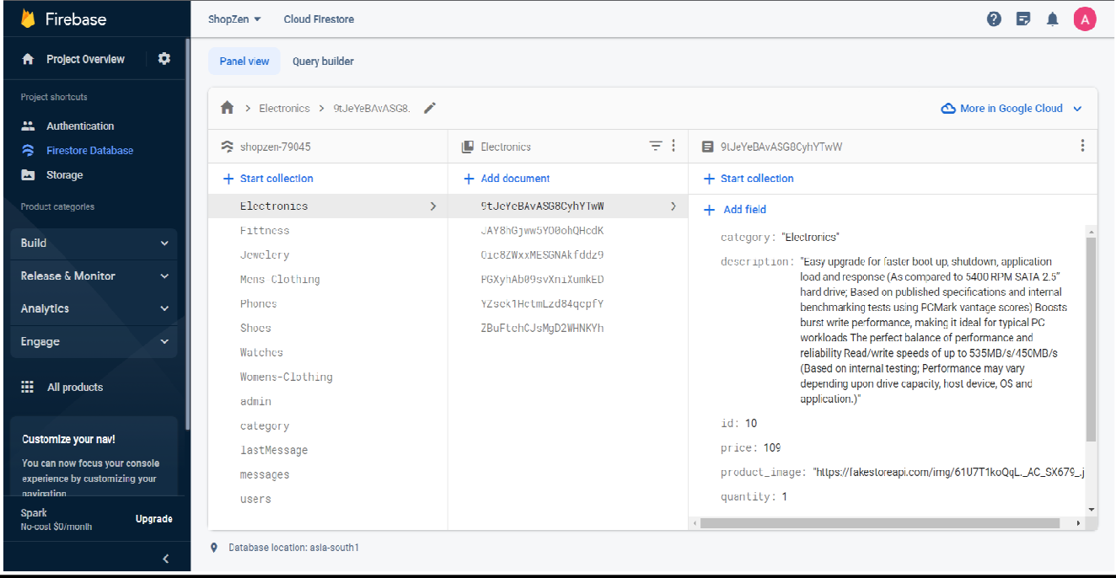

**Users console:**

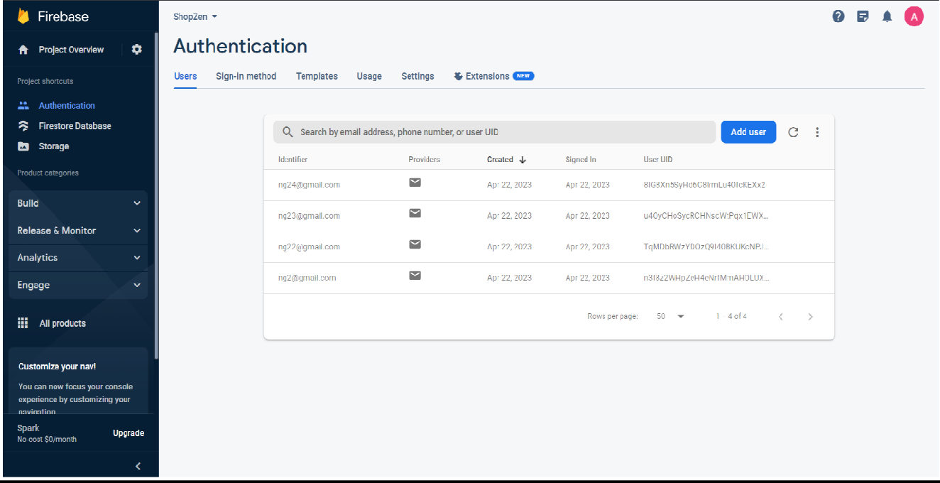

##### Singular User in Database

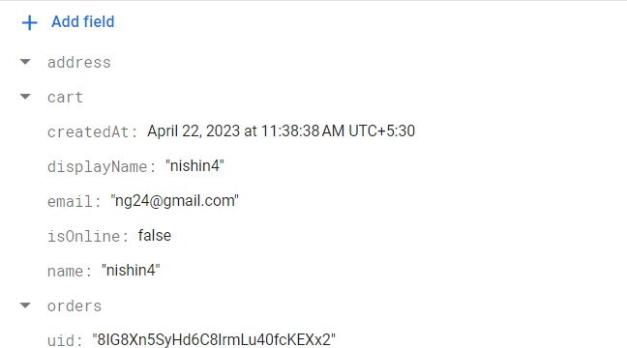

**Singular Product in Database**

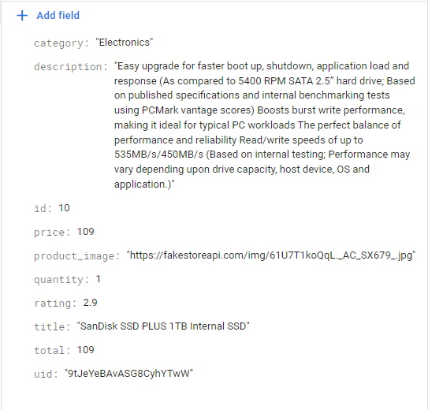

#### Screens

##### Login and otp Screen:

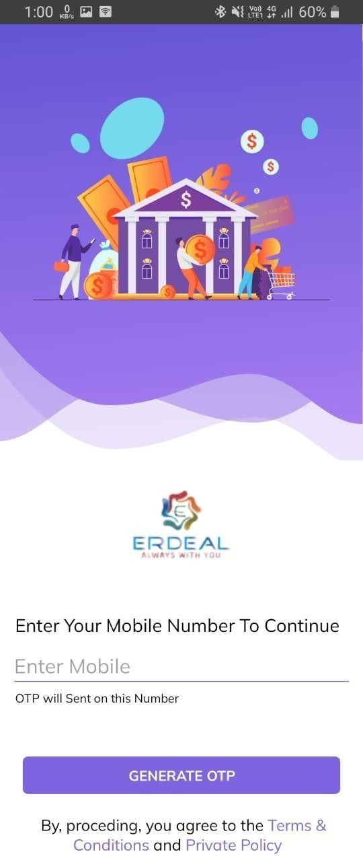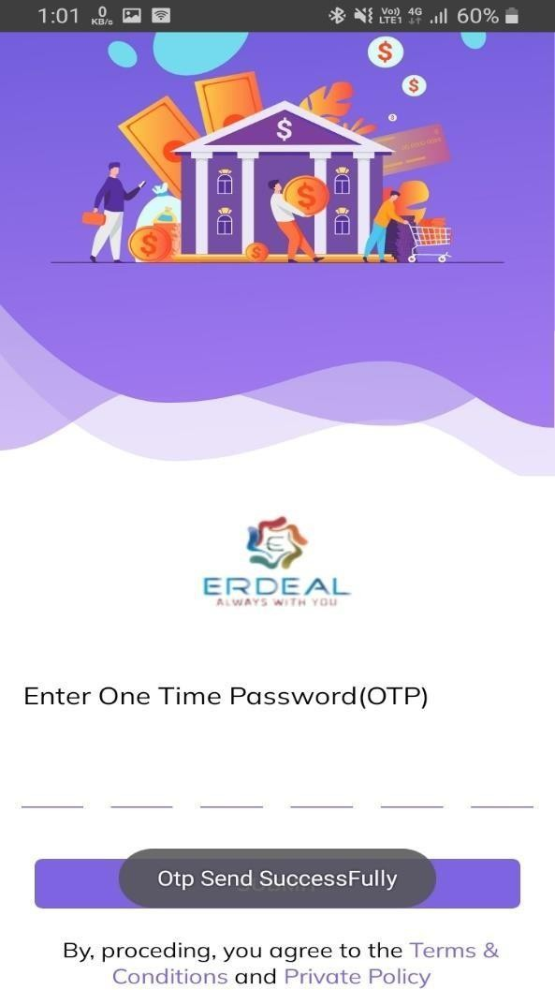

**[Fig.4.3.1: Login and otp screen]**

##### Dashboard And Profile:

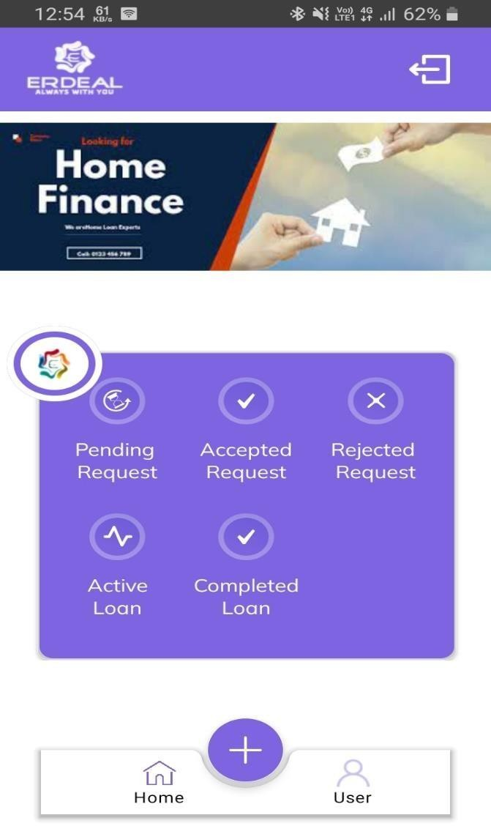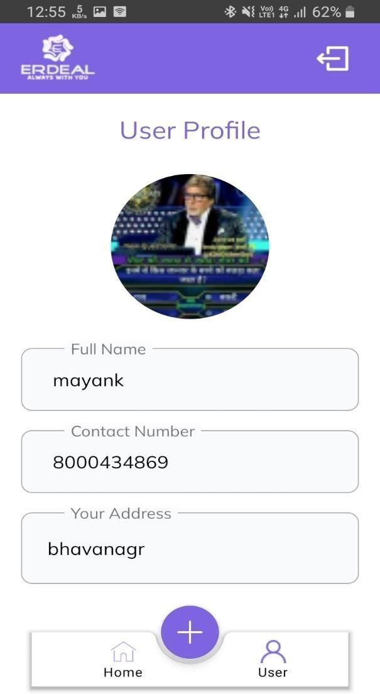

[Fig.4.3.2: Dashboard Profile]

**Loan Application Form:**

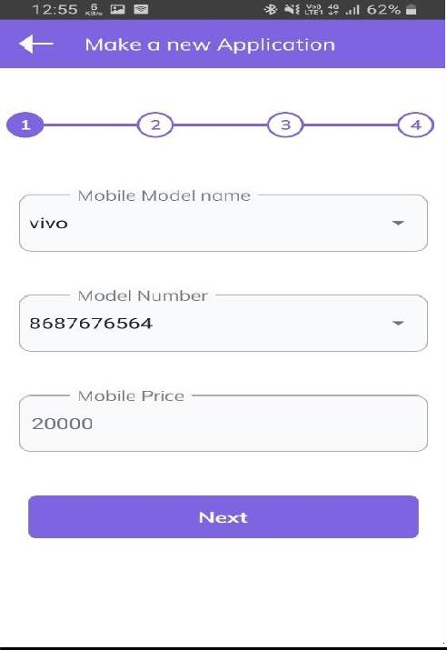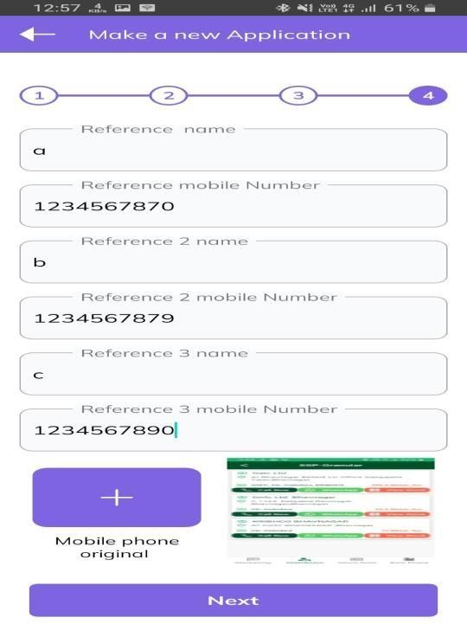

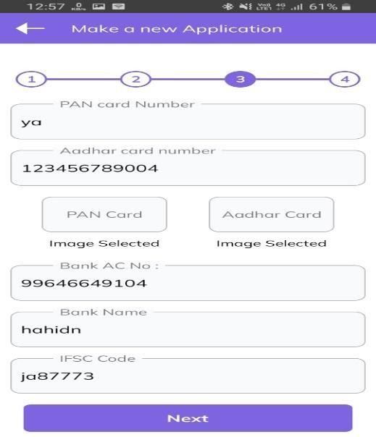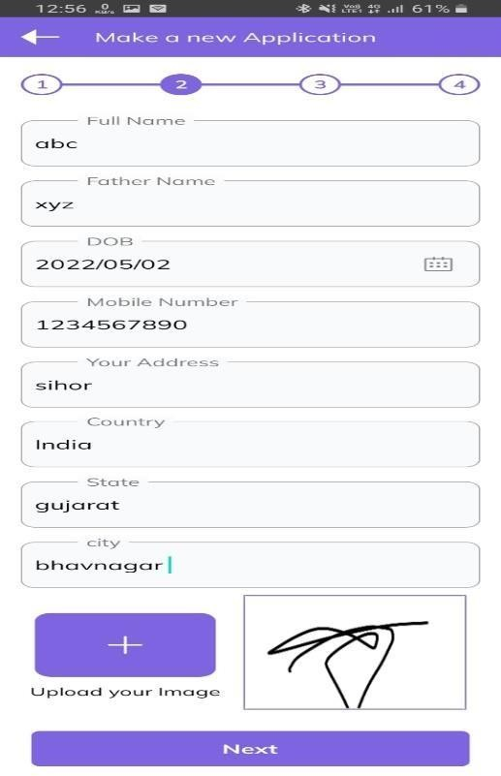

**[Fig.4.3.3:Loan Application Form]**

##### Panding Application:

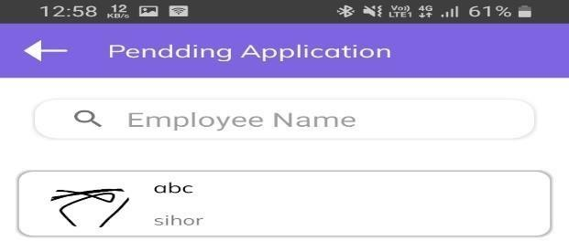

**[Fig.4.3.4:Panding Application]**

##### Accepted Application:

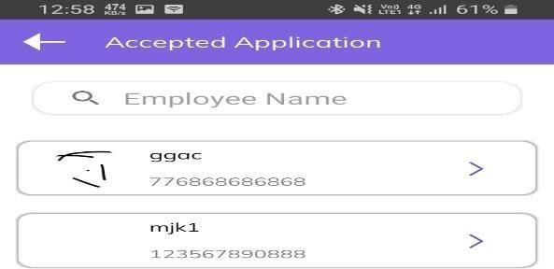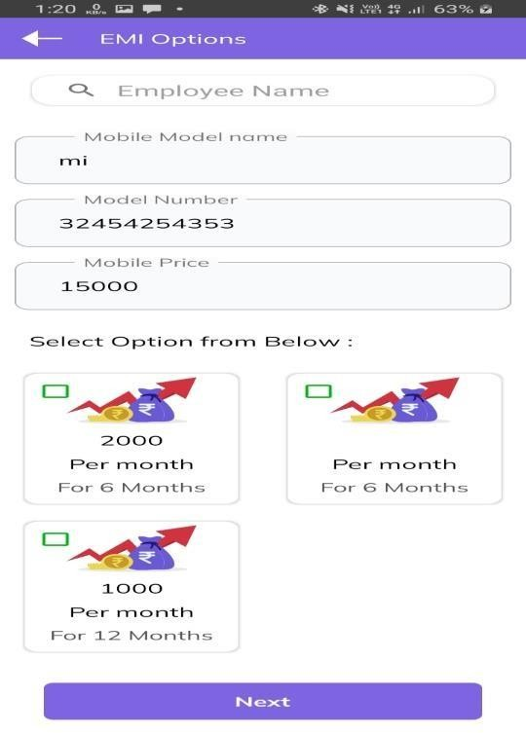

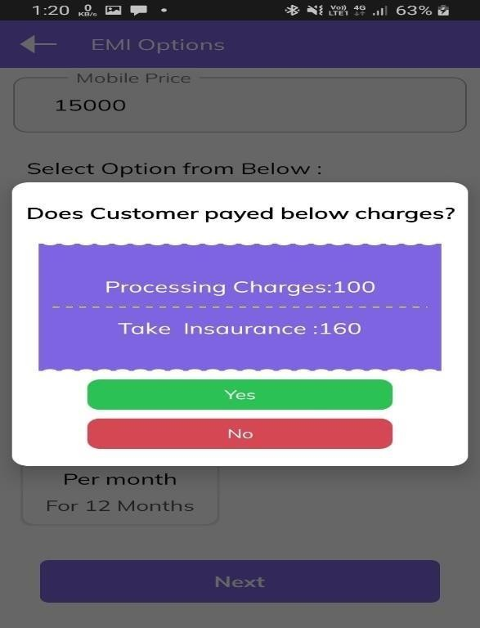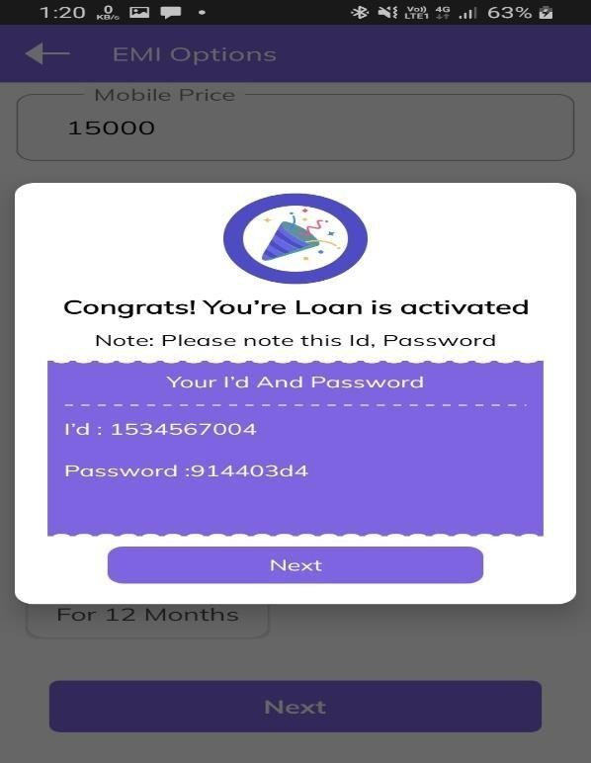

**[Fig.4.3.5: Accepted Application]**

##### Rejected Application:

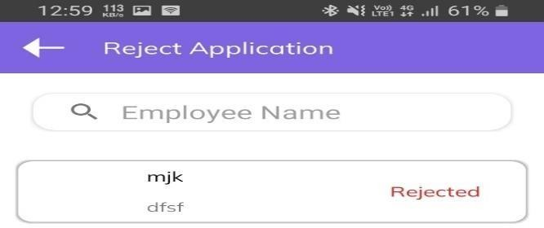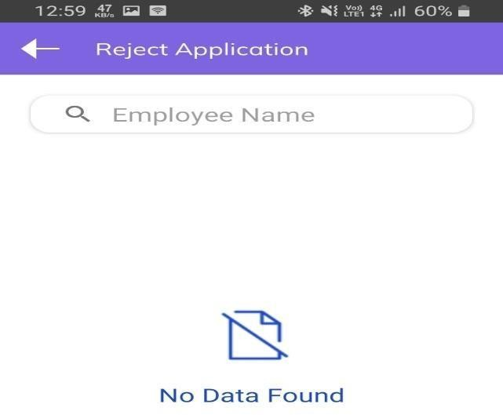

**[Fig.4.3.6: Rejected Application]**

##### Active Loan :

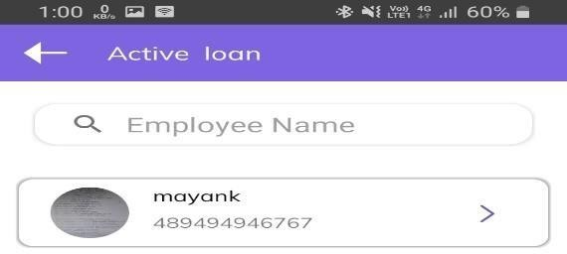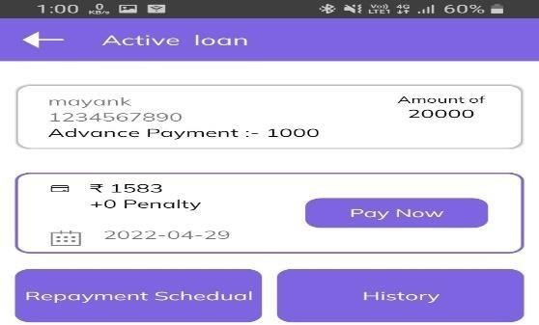

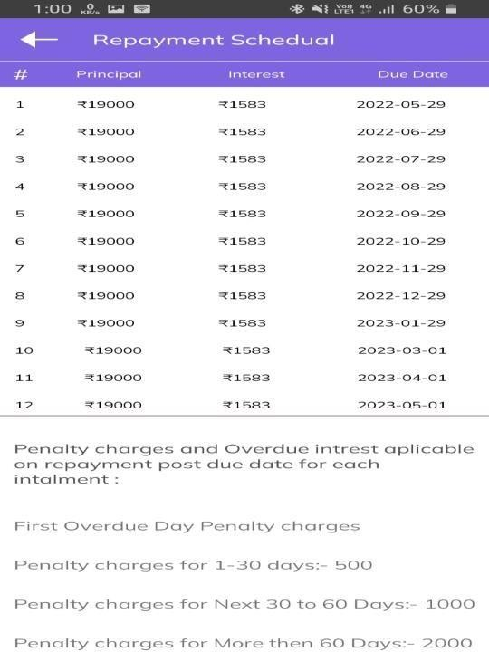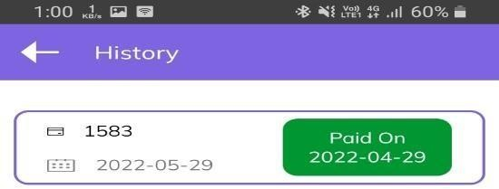

**[Fig.4.3.7: Active Loan]**

##### Completed Loan:

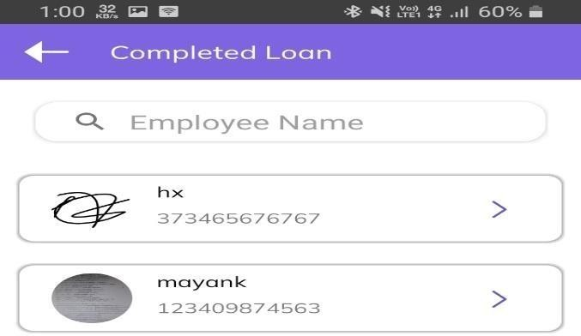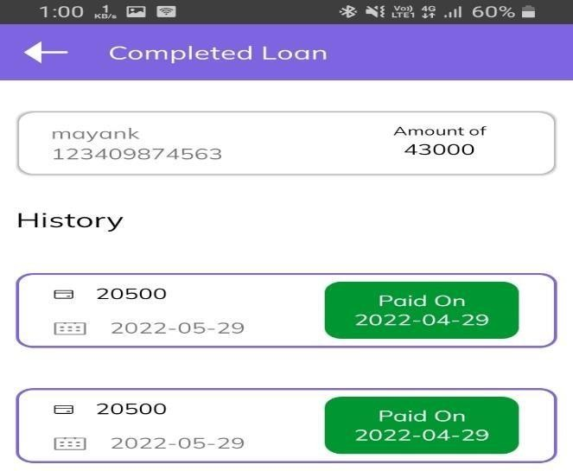

**[Fig.4.3.8: Completed Loan]**

# Chapter 5: Implementation Planning

#### Implementation Environment

* 1. **Program/Modules Specification**

#### Coding Standards

* 1. **Coding Scenario**

#### Implementation Environment

The application is a single-server, multi-client application. Multiple users can log in to use the system.

Multi-user vs. single-user

A single-user web application is designed to serve only one user at a time, while a multi-user web application is designed to be used by multiple users simultaneously. In a single-user web application, the user has exclusive access to the system and can perform any operation in the application without worrying about data conflicts. In a multi-user web application, on the other hand, multiple users can access and use the system simultaneously. The application must handle concurrent access and manage any data conflicts that may arise. Multi-user web applications typically require more complex security and user management features to ensure that the system remains secure and that users can access only the data they are authorized to use.

GUI vs. non-GUI

GUI (Graphical User Interface) and non-GUI are two different approaches to building web applications. GUI-based web applications have a user interface that uses visual elements such as buttons, menus, forms, and images to allow users to interact with the application. Non-GUI web applications, also known as command- line applications, have no graphical interface and rely on text-based input and output.

GUI-based web applications are more user-friendly and intuitive, making it easier for users to navigate and interact with the application. Non-GUI web applications are generally simpler and more streamlined, making them easier to develop and maintain. However, they may not be as accessible to users who are unfamiliar with command-line interfaces.

#### Program/Modules Specification

* + - Web app development made with React.js
    - User Module: - User can purchase products.
    - Admin Module:- Admin can track, change status, view and block user.

#### Coding Standards

Coding techniques incorporate many facts about software development. Although they usually have no impact on the functionality of the application; they contribute to an improved comprehension of source code. All forms of source code are

considered here, including programming, scripting markup, and query languages.

Purpose of Coding Standards and Best Practices

To develop reliable and maintainable applications, you must follow coding standards and best practices. The naming conventions, coding standards and best practices described in this document are compiled from our own experience and by referring to various guidelines. There are several standards that exist in the programming industry. None of them are wrong or bad and you may follow any of them. What is more important is, selecting one standard approach and ensuring that everyone is following it.

In this phase of software development, the design is related to a system converted into a machine-readable code that can be compiled and executed. Although the coding phase does not affect the structure of the system, it has a great impact on the internal structure of the module, which affects the testability, under the stability of the system.

#### Coding Scenario

I used React.js in this web app. This way I made each component reusable and reduced the footprint so that each functionality can be reused when needed.

Also, using Firebase helped make the website secure by storing and authenticating each individual user when they log in and make a purchase.

# Chapter 6: Testing

#### Testing Plan

* 1. **Test Stratergy**

#### Testing Methods

* + 1. **Test Cases**

#### Testing Plan

The objective of the system testing is to ensure that all individual programs are working as expected, that the programs link together to meet the requirements specified and ensure that the computer system and the associated clerical and other procedures work together. Systems are not designed as entire systems but they are tested as single systems. The analyst must perform both unit and system testing.

Different types of testing methods are available. We have tested our system for different aspects like Does the system meet the goals for which it has been designed? This was a very important question that stood before us as the system was designed to be implemented on such a large network.

To fulfill its goal of being able to run on different systems we went through a series of tests at different places where this is supposed to be used the most. As we need to make our system efficient enough, we need to test it thoroughly.

Finally, we tested the system with real-time data, for which it is actually designed. We are successful in satisfying our needs as it was designed according to client's requirements. But it is very necessary to maintain this system and so our work is not still over.

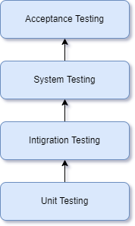

#### Testing Strategy

Once source code has been generated, the software must be tested to uncover as many errors as possible before delivery to the customer. Our goal is to design a series of test cases that have a high likelihood of finding errors. Software testing techniques provide systematic guidance for designing tests that (1) Exercise the internal logic of software components (2) Exercise the inputs and outputs domains of the program to uncover errors in program function, behaviour and performance.

During the early stages of testing, a software engineer performs all tests. However, as the testing process progresses, testing specialists may become involved. Reviews and other activities can and do uncover errors, but they are not sufficient. Every time the program is executed, the customer tests it! Therefore, you have to execute the program before it gets to the customer with the specific intent of finding and removing all errors. In order to find the highest possible number of errors, tests must be conducted systematically and test cases must be designed using disciplined techniques.

* + 1. Testing Objectives

Testing is a process of executing a program with the intention of finding an error. A good test case is one that has a high probability of finding an as-yet undiscovered error.

A successful test is one that uncovers an as-yet undiscovered error.

* + 1. Unit Testing

Unit testing is a software development process in which the smallest testable part of an application, called units, are individually scrutinized for proper operation. Unit testing is often automated but it can also be done manually. This testing mode is a component of Extreme Programming (XP), a pragmatic method of software development that takes a meticulous approach to building a product by means of continual testing and revision.

Unit testing involves only those characteristics that are vital to the performance of the unit under test.

This encourages developers to modify the source code without immediate concerns about how such changes might affect the functioning of the units or the program as a whole. Once all of the units in a program have been found to be working in the most efficient and error free manner possible, larger components of the program can be evaluated by means of integration testing.

* + 1. System Testing

Now, it’s time for whole System testing. We have found some cosmetic bugs and minor bugs. We have fixed it and tested it again. We worked on each error and exception that we got while testing and most of them are resolved or handled programmatically.

* + 1. Recovery Testing

It is a system test that forces the software to fail in a variety of ways and verifies that recovery is properly performed.

* + 1. Performance Testing

It is designed to test the run-time performance of software within the context of an integrated system performance testing occurs throughout all steps in the testing process.

#### Testing Methods

Acceptance Testing

Acceptance testing can be connected by the end user, customer, or client to validate whether or not to accept the product. Acceptance testing may be performed as part of the hand-off process between any two phases of development. The acceptance test suite is run against the supplied input data or using an acceptance test script to direct the tester. Then the results obtained are compared with the expected results. If there is a correct match for every case, the test suite is said to pass.

Alpha & beta testing

The alpha test is conducted at the developer’s site by a customer. The software is used in a natural setting with the developer

“looking over shoulder” of the user and recording errors and usage problems.

Alpha test is conducted in a controlled environment. The beta testing is conducted at one or more customer sites by the end-user of the software. Unlike alpha testing, the developer is generally not present. Therefore, the beta test is a “live” application of the software in an environment that cannot be controlled by the developer.

Black-box testing

Also known as functional testing. Software testing techniques where by the internal working of the item being tested are not known by the tester. For example, in a black box test on software design the tester only knows the inputs and what the expected outcomes should be and not how the program arrives at those outputs. The tester does not ever examine the programming code and does not need any further knowledge of the program other than its specification.

The advantages of this type of testing include:

* The test is unbiased as the designer and the tester are independent of each other.
* The tester does not need knowledge of any specific programming languages.
* The test is done from the point of view of the user, not the designer. Test cases can be designed as soon as the specifications are complete.

The disadvantages of this type of testing include:

* The test can be redundant if the software designer has already run a test case.
* The test cases are difficult to design. Testing every possible input stream is unrealistic because it would take an inordinate amount of time: hence many program paths will go untested.

White Box Testing

Also known as glass box, structural, clear box and open box testing. A software testing technique where by explicit knowledge of the internal workings of the item being tested are used to select the test data. Unlike black box testing, white box testing uses specific knowledge of programming code to examine outputs. The test is accurate only if the tester knows what the program is supposed to do.

#### Test Cases

To minimize the number of errors in software, a rich variety of test design methods have evolved for software. These methods provide the developer with a systematic approach to testing. More importantly, methods provide a mechanism that can help to ensure the completeness of the test and provide the highest likelihood for uncovering errors in software.

An engineering product can be tested in one of the two ways:

Knowing the specified function that product has been designed to perform, tests can be conducted that demonstrate each function is fully operational while at the same time searching for errors in each function.

Knowing the internal workings of a product, tests can be conducted to ensure that “all gear mesh “, that is, internal oppression are performed according to specifications and all internal components have been adequately exercised. Here are the test cases that we had made for our application.

Test Case For Login

* Check the Email
* Check Password

Test Case For Sign Up

* Input username and email check if they are duplicate in database
* Input atleast 6 digit password.
* All this field are required.

Test Case Purchase

* Check if logged in and if product is available in inventory.
* Input address, state, city, pin code and mobile number correctly.
* Enter correct card number if purchasing through online payment.

**Chapter 7: Limitations and Future Enhancement**

#### Limitations

* 1. **Future Enhancement**

#### Limitations

* + - Without Internet website is not accessible.
    - Admin needs to be online to chat with customer.
    - Users are expected to insert correct address.

#### Future Enhancement

* + - Product review.
    - AI generated answers in customer service chat.

## Chapter 8: Conclusion

#### 8.1 Conclusion

**Conclusion**

In this app admin is main part of this application.in this app I learn lots of thing in this loan application. Finlay I complete this project and client are very satisfied for this loan application.

##### REFERENCES

1. Quora. (2009) For Solution of Question

**[Online] [Accessed from February to April 2022]**

<https://www.quora.com/>

1. Stack Overflow. (2008) Coding Related Question Solution [Online] [Accessed from February to April 2022]

<https://stackoverflow.com/>

1. **GitHub. (2007) GitHub Support Community [Online] [Accessed from February to April 2022]** [https://github.community](https://github.community/)
2. Android Tutorial

**[Online] [Accessed from February to April 2022]**

<https://www.android.net/>

1. Google Drive API. [~2012] To read, write, and sync files in Google Drive. [Online] [Accessed from February to April 2022]

<https://developers.google.com/drive/api/v3/about-sdk>